Lesson 15: Using the Quadratic Formula

Classwork

Opening Exercise

Solve the following:

$4x^{2}+5x+3=2x^{2}-3x$

$c^{2}-14=5c$

**Exercises**

Solve Exercises 1–5 using the quadratic formula.



$x^{2}-2x+1=0$

${3b}^{2}+4b+8=0$

$2t^{2}+7t-4=0$

$q^{2}-2q-1=0$

$m^{2}-4=3$

For Exercises 6–9, determine the number of real solutions for each quadratic equation without solving.

$p^{2}+7p+33=8-3p$

$7x^{2}+2x+5=0$

$2y^{2}+10y=y^{2}+4y-3$

$4z^{2}+9=-4z$

4. On the line below each graph, state whether the discriminant of each quadratic equation is positive, negative, or equal to zero. Then, identify which graph matches the discriminants below.

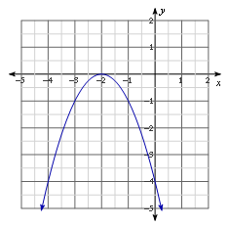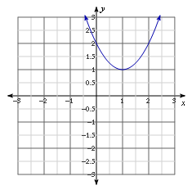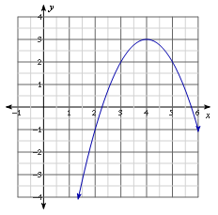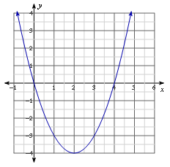

Graph 1 Graph 2 Graph 3 Graph 4

_____________________ ______________________ _______________________ ______________________

|  |  |  |  |
| --- | --- | --- | --- |
| Discriminant A: $${\left(-2\right)}^{2}-4\left(1\right)\left(2\right)$$ Graph: ______ | Discriminant B: $${\left(-4\right)}^{2}-4\left(-1\right)\left(-4\right)$$ Graph: ______ | Discriminant C: $${\left(-4\right)}^{2}-4\left(1\right)\left(0\right)$$ Graph: ______ | Discriminant D: $${ \left(-8\right)}^{2}-4\left(-1\right)\left(-13\right)$$ Graph: ______ |

1. Consider the quadratic function $f\left(x\right)=x^{2}-2x-4$.
   1. Use the quadratic formula to find the $x$-intercepts of the graph of the function.
   2. Use the $x$-intercepts to write the quadratic function in factored form.
   3. Show that the function from part (b) written in factored form is equivalent to the original function.

**Extension:** Consider the quadratic equation $ax^{2}+bx+c=0$.

1. Write the equation in factored form, $a\left(x-m\right)\left(x-n\right)=0$, where $m$ and $n$ are the solutions to the equation.
2. Show that the equation from part (a) is equivalent to the original equation.

Lesson Summary

You can use the sign of the discriminant, $b^{2}-4ac$, to determine the number of real solutions to a quadratic equation in the form $ax^{2}+bx+c=0$, where $a≠0$. If the equation has a positive discriminant, there are two real solutions. A negative discriminant yields no real solutions, and a discriminant equal to zero yields only one real solution.

Problem Set

Without solving, determine the number of real solutions for each quadratic equation.

$b^{2}-4b+3=0$

$2n^{2}+7=-4n+5$

$x-3x^{2}=5+2x-x^{2}$

$4q+7=q^{2}-5q+1$

Based on the graph of each quadratic function, $y=f(x)$, determine the number of real solutions for each corresponding quadratic equation, $f(x)=0$.

|  |  |  |  |
| --- | --- | --- | --- |
|  |  |  |  |
|  |  |  |  |
|  |  |  |  |

1. Consider the quadratic function $f\left(x\right)=x^{2}-7$.
   1. Find the $x$-intercepts of the graph of the function.
   2. Use the $x$-intercepts to write the quadratic function in factored form.
   3. Show that the function from part (b) written in factored form is equivalent to the original function.
2. Consider the quadratic function $f\left(x\right)=-2x^{2}+x+5$.
   1. Find the $x$-intercepts of the graph of the function.
   2. Use the $x$-intercepts to write the quadratic function in factored form.
   3. Show that the function from part (b) written in factored form is equivalent to the original function.